ST10461472

Matimba Luchen

WEDE5020 – POE PART 3

Table of Contents

**Name: Tropi Graze Farm** 3

**Description** 3

**Reason for Choosing Tropi Graze** 3

**Website Assets** 4

**Website Content and Pages** 5

1. Homepage 5

**2.** **About Us:** 5

**3.** **Product Catalogue** 5

**4.** **Inside Tropi** 5

**5.** **Contact** 5

**References** 5

**PART 2** 6

**Improvements made to part one** 6

**PART 3** 7

**Improvements made to part 2 word document** 7

**Functionality** 7

**SEO** 8

# **Name: Tropi Graze Farm**

# **Description**

Tropi Graze Farm is a dynamic agricultural enterprise located in [Insert location if known], specializing in a diverse range of both livestock and crop production. The farm prides itself on providing high-quality products including pigs, sheep, goats, fish, and a variety of fruits and vegetables like bananas, pawpaws, and banana suckers. Additionally, Tropi Graze offers breeding stocks that are particularly suited to local conditions, catering to smallholder farmers who are keen on increasing their income and transitioning towards resilient farming practices. The farm’s livestock includes Boer goat crosses, Dorper sheep crosses, Speckled sheep crosses, turkeys, geese, ducks, guinea fowls, and improved traditional chickens, making it a veritable “Noah’s Ark” of livestock options. Tropi Graze is committed not just to selling these products, but also to sharing the knowledge and experience necessary for their customers’ success, working with a range of clients from individual farmers to cooperatives and NGOs.

# **Reason for Choosing Tropi Graze**

The choice to develop a website for Tropi Graze Farm is grounded in the need to enhance the farm’s online presence, thereby expanding its reach to a broader audience. In today’s digital age, having a well-structured website is essential for any business looking to thrive and grow. For Tropi Graze, this website will serve as a powerful tool to streamline operations, increase sales, and improve customer engagement. Furthermore, I chose Tropi Graze Farm for this project because of their unique blend of traditional farming practices and modern

entrepreneurial spirit. As a family business, Tropi Graze's story is rooted in passion, dedication, and a strong work ethic. Through this project, I hope to help Tropi Graze Farm expand its customer base, increase sales, and solidify its position as a leading provider of tresh and healthy farm products. Ultimately, I believe that this project will contribute to the growth and success of the business while promoting sustainable agriculture and supporting the local community.

**Website Assets**

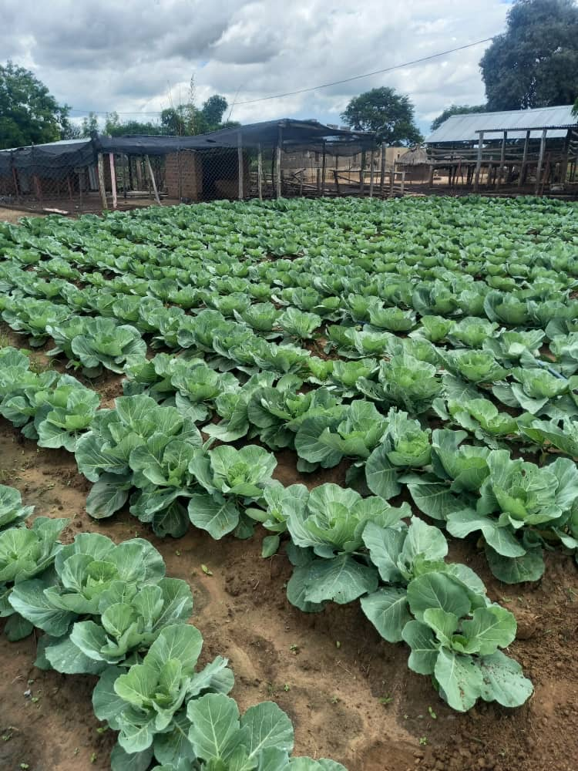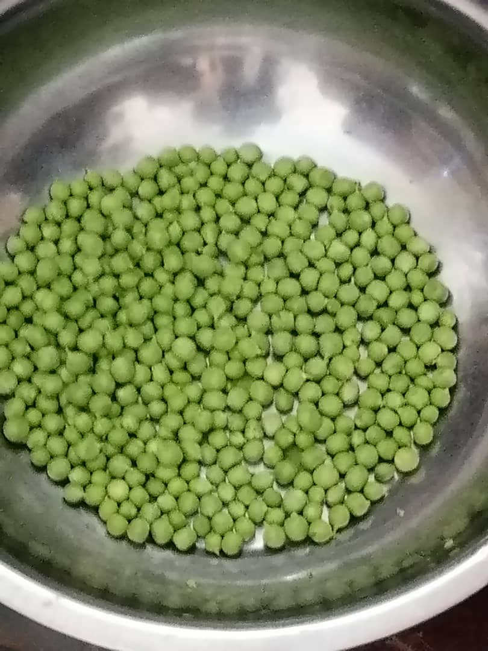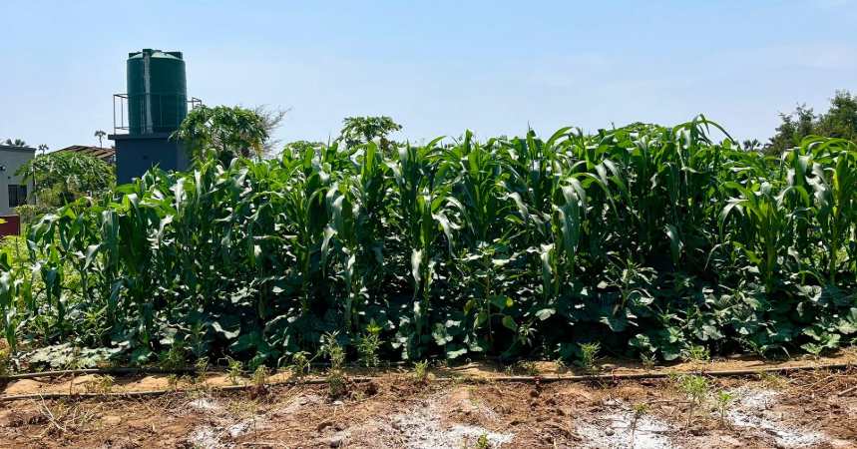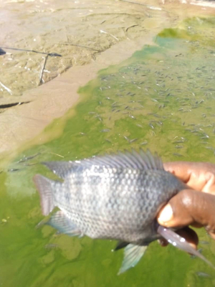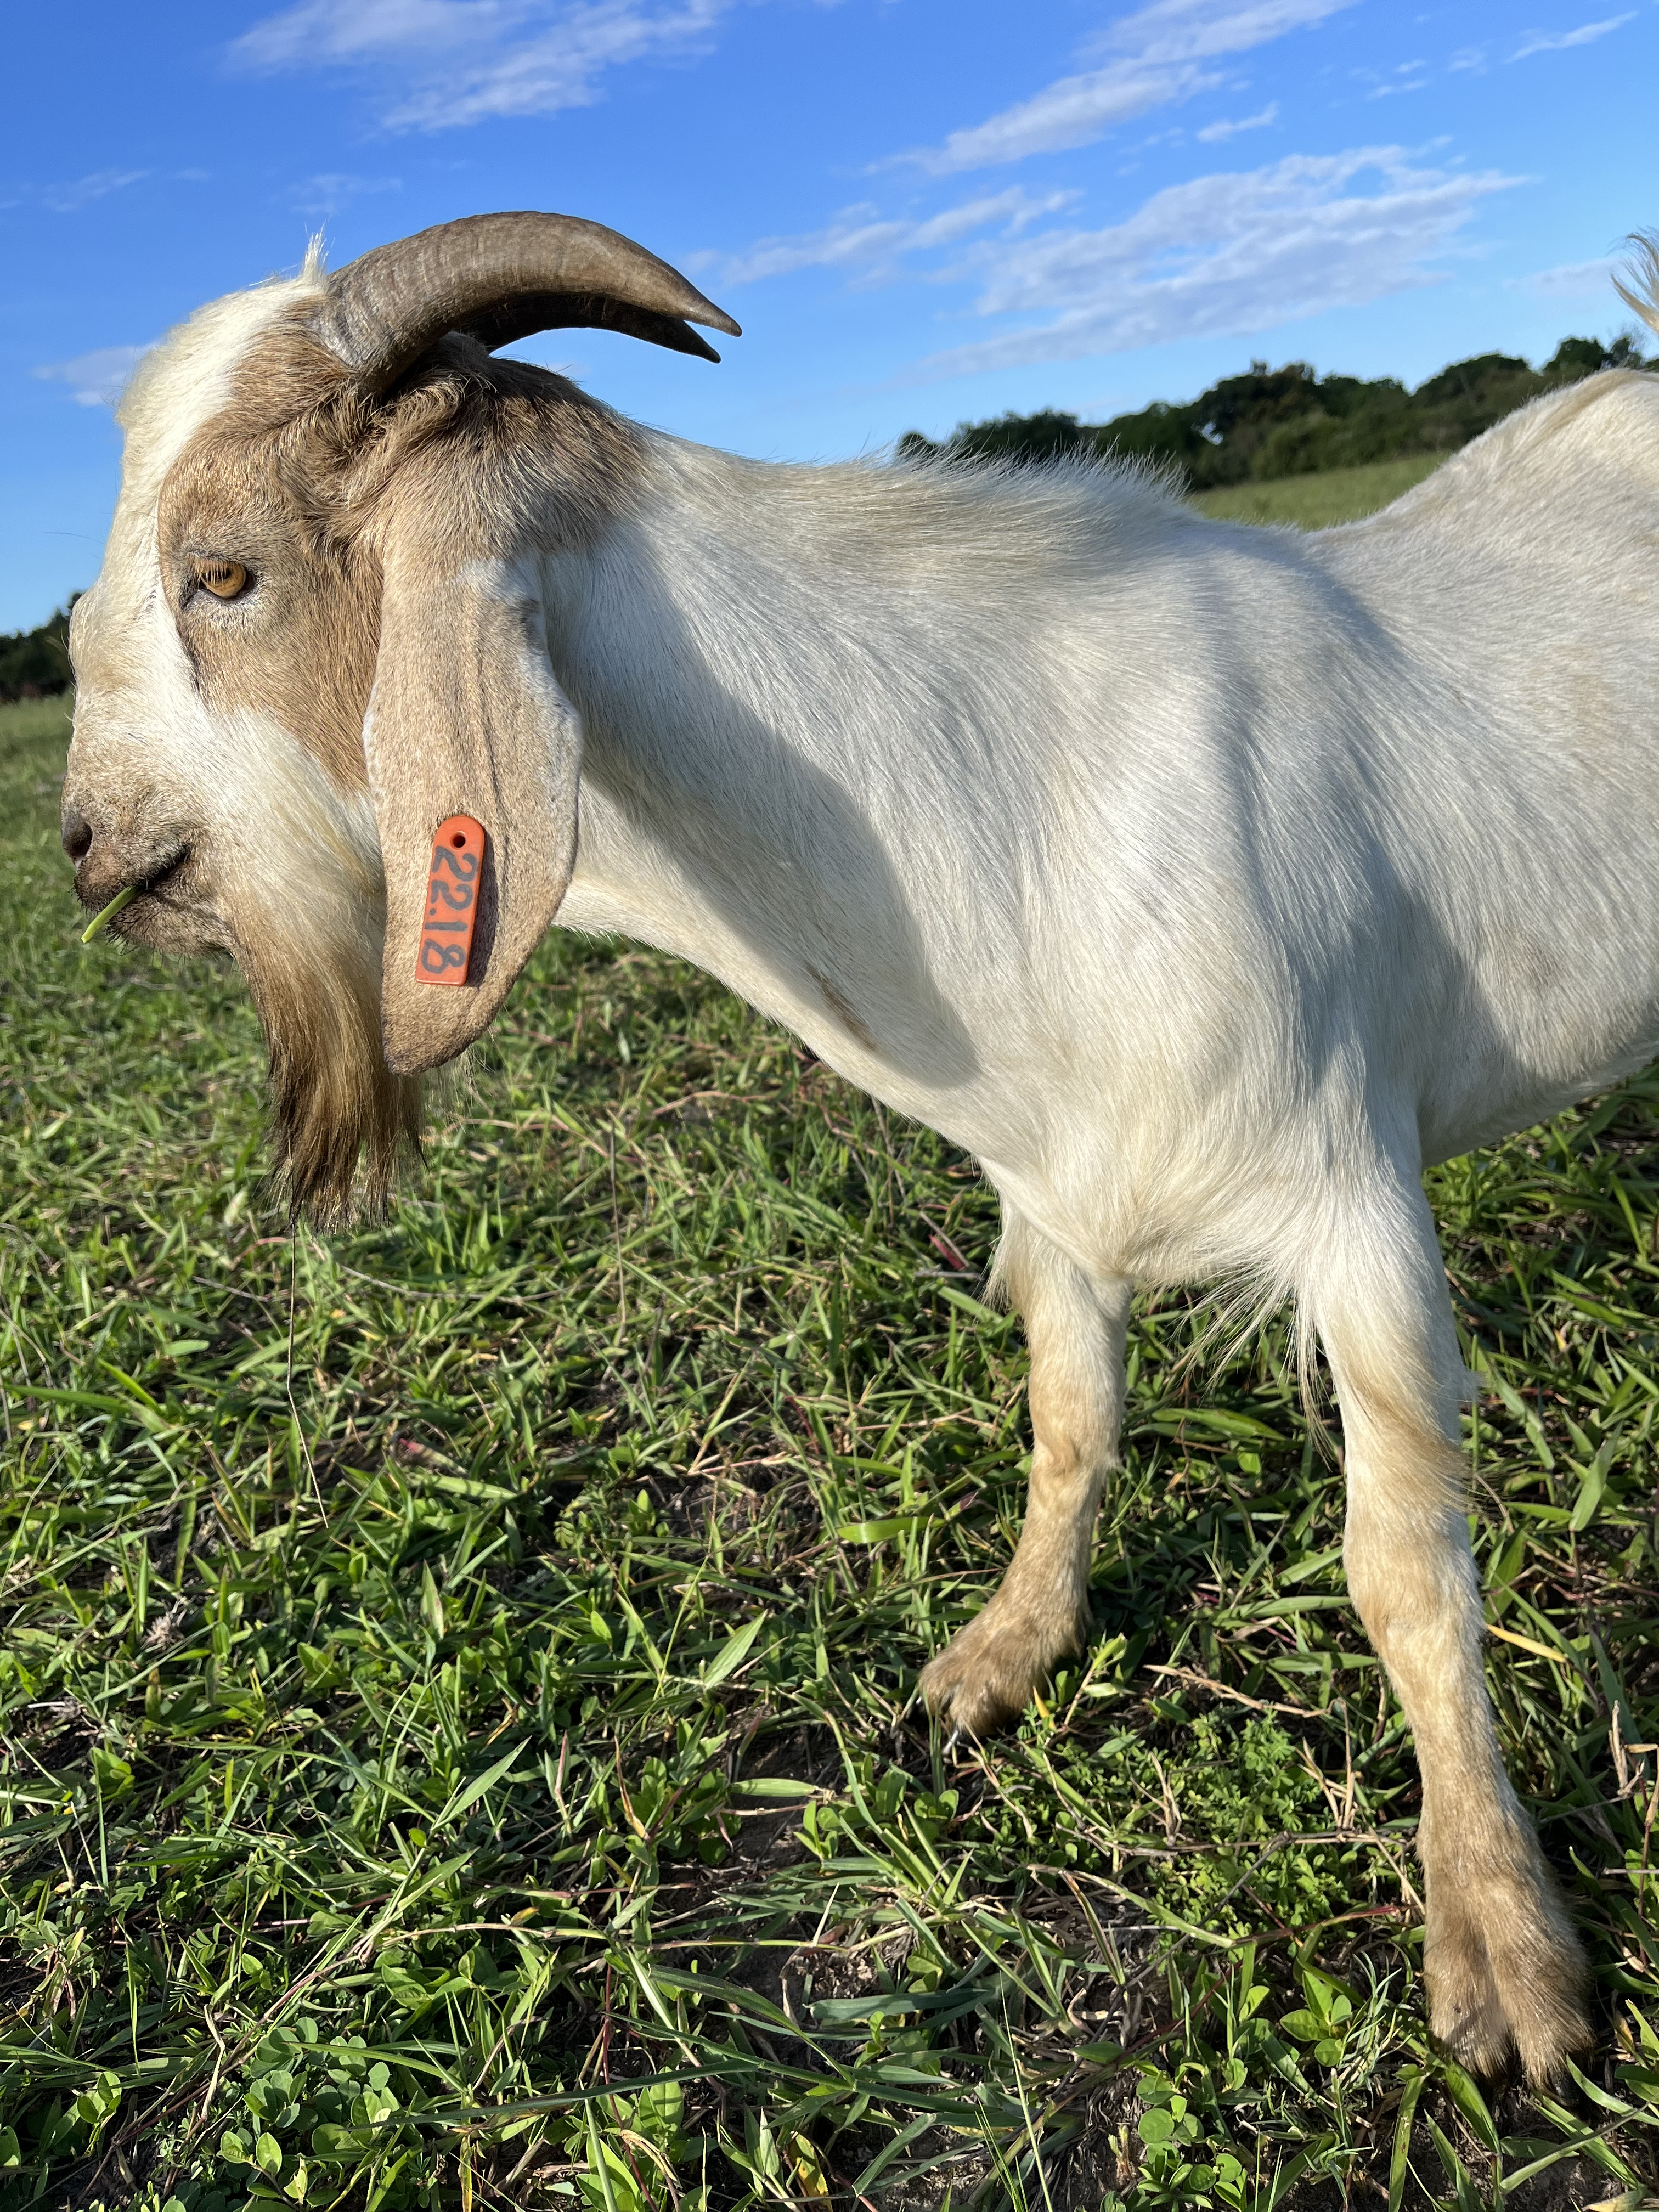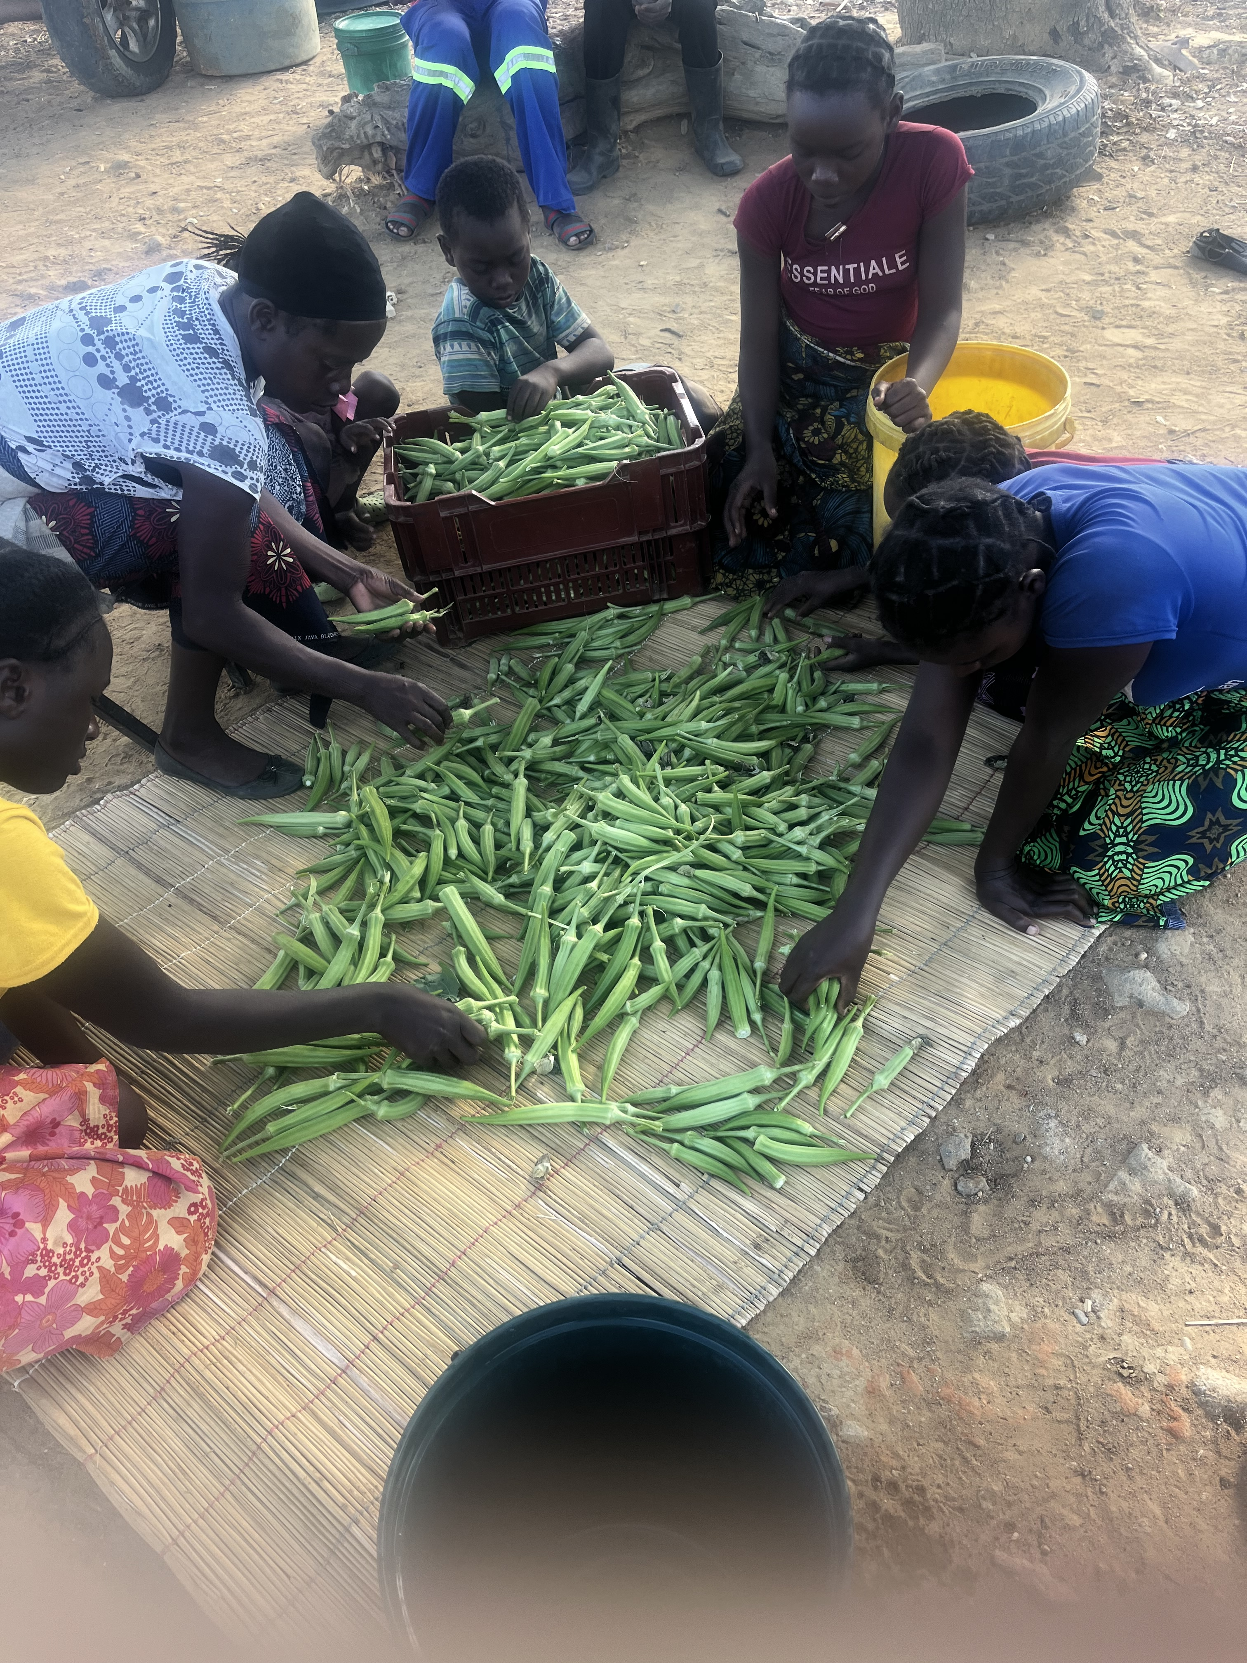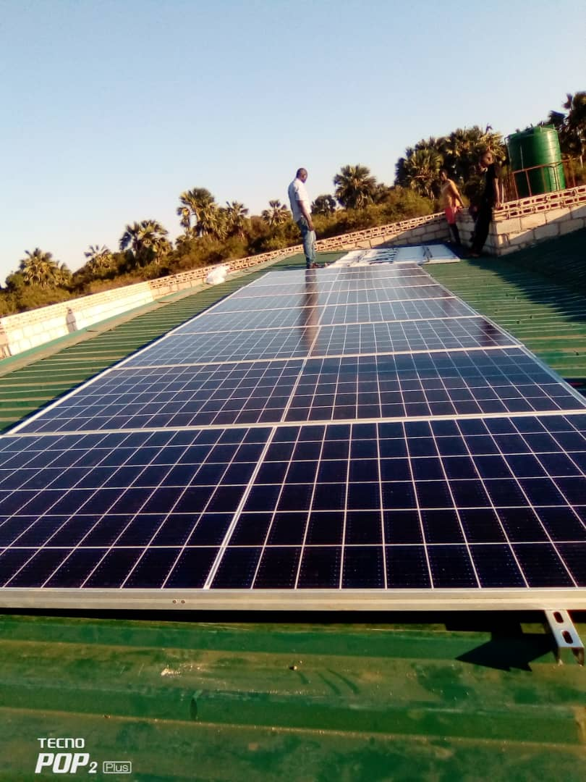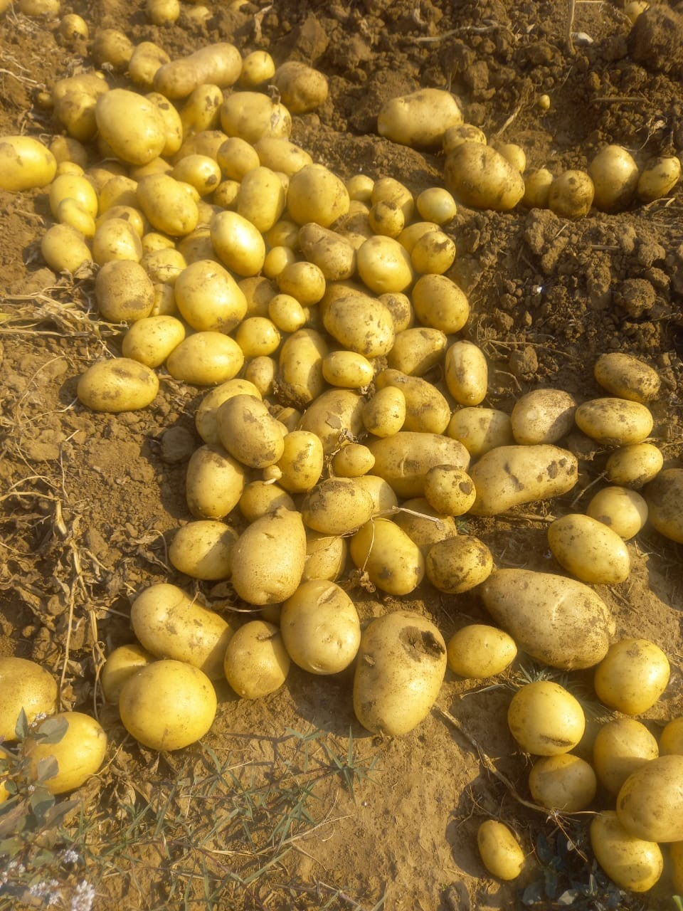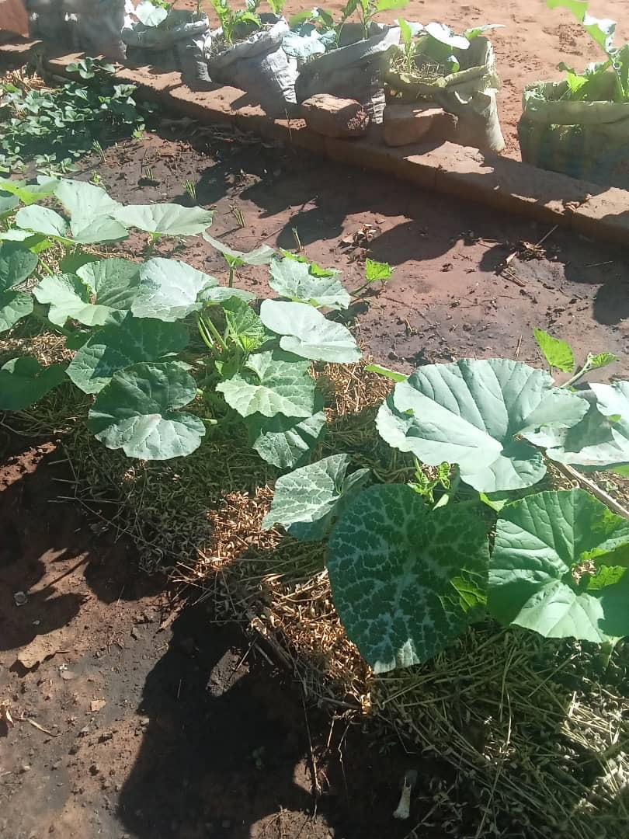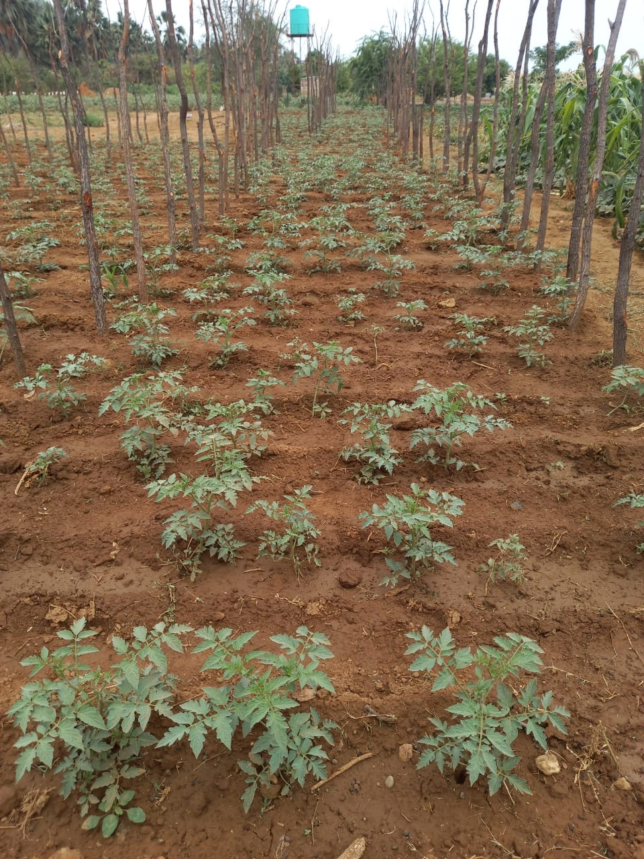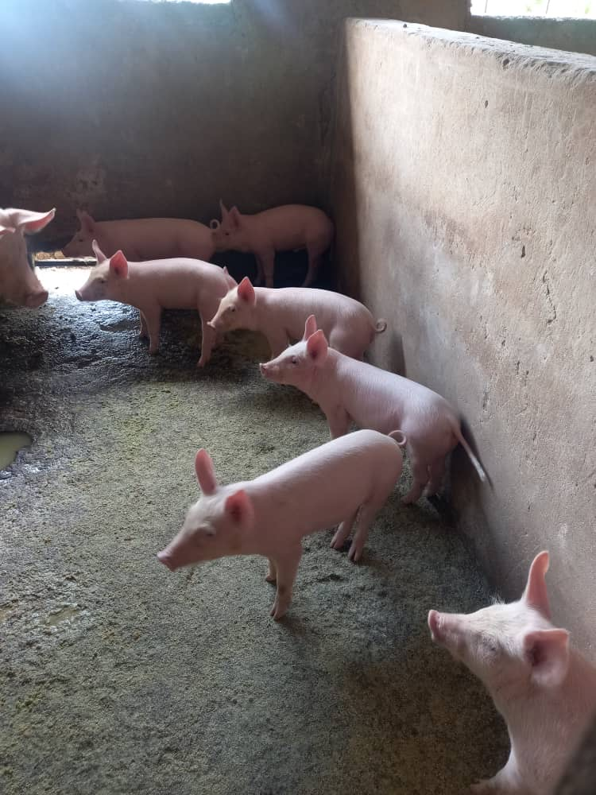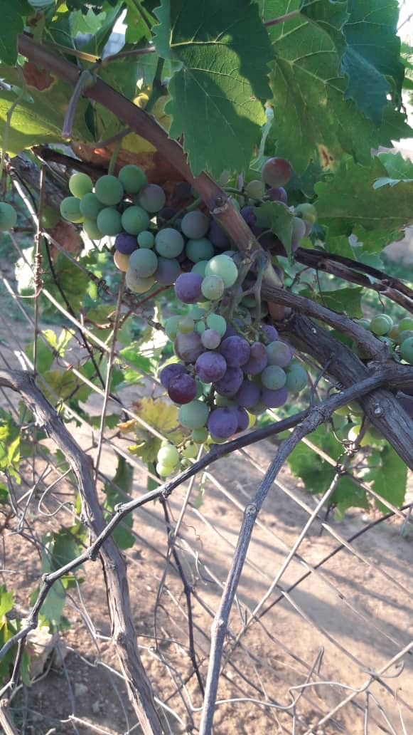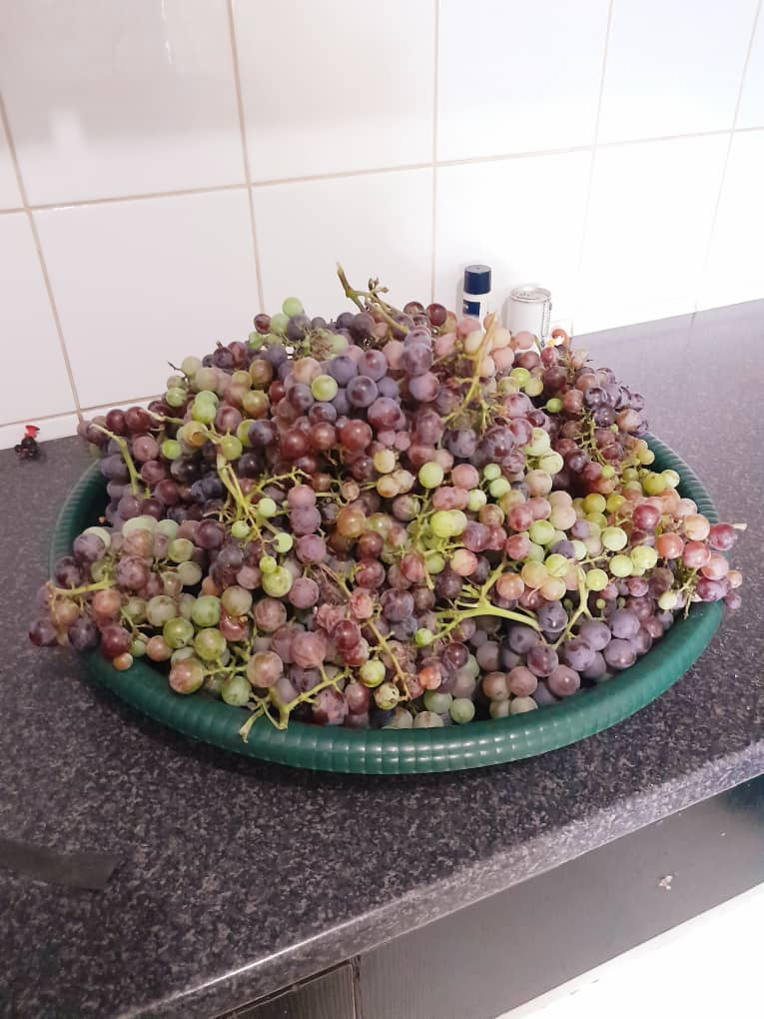

# **Website Content and Pages**

1. Homepage:

* A logo of the business
* Links to main sections (About Us, products, inside Tropi, Contact)
* ﻿﻿A featured product, which is a hero image of a maize field
* ﻿﻿A brief overview of the business
* ﻿﻿Brief contact information
* Copyright information

## **About Us:**

* ﻿﻿Mission, goals and values.
* Links to main sections (About Us, products, inside Tropi, Contact)

1. **Product Catalogue:**

* ﻿﻿Livestock (with descriptions and images).
* ﻿﻿Fruits and Vegetables (with descriptions and images)
* ﻿﻿ availability information.
* Links to main sections (About Us, products, inside Tropi, Contact)

## **Inside Tropi**

* Display of the farm operations (images with descriptions). Behind the scenes of the product
* Links to main sections (About Us, products, inside Tropi, Contact)

## **Contact**

* ﻿﻿Contact information
* Links to main sections (About Us, products, inside Tropi, Contact)

# **References**

Not applicable because photos used are my own

# **PART 2**

## **Improvements made to part one**

In this version of the website, several significant improvements were made to improve both functionality and aesthetics. One of the key updates was the addition of hover effects to the navigation bars. When users hover over the navigation links, the background now transitions to a light shade of grey while the text turns green. This effect provides visual feedback, improving interactivity and guiding user engagement more effectively. The hover effect was also applied to the grid items, which now slightly enlarge on hover, making the content more visually appealing and dynamic. Thus, the website is now responsive,

Another improvement was the increase in font sizes for the navigation bar on the home screen, making the text more readable and prominent. Alongside this, the business name and logo were aligned to the centre of the header, creating a balanced and professional layout. These changes ensure a cleaner, more organised structure, which is easier to navigate and leaves a strong impression on users.

A layout improvement was made to the values section of the website. In the first version, the values were displayed in a vertical format, which took up unnecessary space and appeared disjointed. Now, the values are presented in a clean, horizontal list format, making them more logical and easier for users to read. This modification contributes to a more efficient use of space and improves the overall readability of the content.

Additionally, a separate external CSS stylesheet was added to the code, linking all the website’s pages to a single style sheet. This streamlined the process of applying consistent styling across all web pages and improved overall efficiency. The external CSS file allows for easier maintenance and makes future changes to the site’s design simpler to implement.

In summary, these updates ranging from hover effects and font size adjustments to better content alignment and improved value presentation have significantly boosted the usability, interactivity, and visual appeal of the website. The changes ensure a more user-friendly experience across both desktop and mobile platforms.

# **PART 3**

# **Improvements made to part 2 word document**

The overall feedback on part two word document was good, except for a few grammatical errors which I have corrected

# **Improvements made to part 2 word website**

Dynamic Greeting: I implemented a dynamic greeting on the homepage using JavaScript, which changes based on the time of day. The greeting now reads, “Good Morning! Welcome to Tropi Graze”, “Good Afternoon! Welcome to Tropi Graze”, or “Good Evening! Welcome to Tropi Graze” when the user visits the site. The dynamic greeting adds a personal touch to the website, making visitors feel welcome.

SEO Best Practices: I implemented changes such as optimizing image alt attributes, improving Meta descriptions, and updating titles to be more descriptive and include key words. This enhances the website’s visibility on search engines

Customer Contact Form: I created a basic customer contact form on the “Contact” webpage, it includes fields for name, email, message, and a subject line. The form uses the mailto: action for submission and includes basic JavaScript validation.

Google Form Integration: I created a “Receive Newsletter” Google form and embedded it in the footer of the homepage. The form includes an email field and a checkbox for users to opt-in to receive the weekly newsletter.

# **Functionality**

**Lightbox Functionality**

The lightbox feature implemented on the products page enhances the user experience by allowing customers to view product images in a larger format without leaving the page. When a user clicks on a product image, the lightbox opens, displaying the image prominently along with navigation controls to zoom in and out. I implemented a jQuery script to manage the behaviour of the lightbox. This functionality provides an interactive way for users to visually engage with the products and provides better presentation of them. The lightbox is created using a combination of HTML, CSS for styling, and JavaScript for handling the opening and closing actions. I added a class to the product images (product.html) to enable the lightbox functionality. Each product image now includes a link that wraps around it, this triggers the lightbox when clicked.

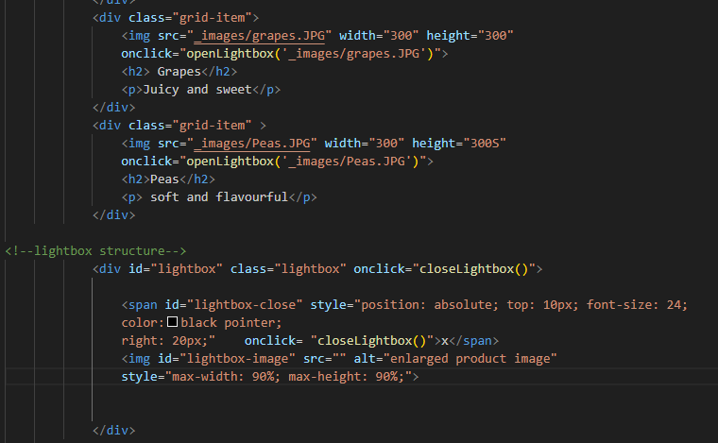html code for lightbox

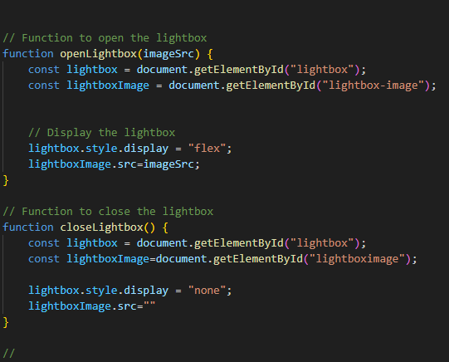 Corresponding JavaScript code for lightbox

**HTML Form with JavaScript Validation**

The customer contact form on the “Contact” webpage collects essential information from users, such as their name, email address, and inquiries about products or services. It incorporates basic JavaScript validation to improve user input accuracy. When the user clicks on a text field, the initial value is cleared, encouraging them to enter their information. Additionally, the form checks for critical fields, such as the name and email, and activates a pop-up warning if these fields are left empty upon submission. This validation ensures that users provide necessary information before proceeding, enhancing the form’s effectiveness.

**Greeting with JavaScript**

The dynamic greeting message on the homepage personalizes the user experience by displaying a message based on the time of day. It welcomes users with a friendly “Good Morning!”, “Good Afternoon!”, or “Good Evening!” depending on the current hour. This functionality is achieved using JavaScript, which checks the hour when the page is loaded and updates the greeting message accordingly. The greeting is displayed in a designated <div> element on the homepage, providing an inviting atmosphere for visitors

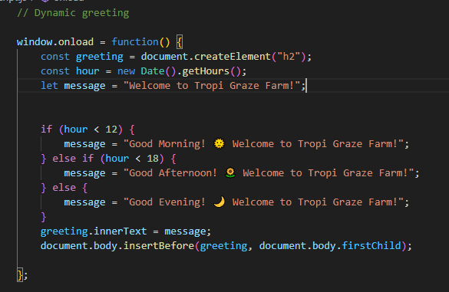

# **SEO**

In optimising the Tropi Graze Farm website for search engines, several SEO best practices were applied. The use of descriptive title tags, such as “Tropi Graze Farm | Sustainable Livestock and Crop Production,” helps convey the website’s purpose to search engines. A concise meta description, like “Tropi Graze Farm specializes in sustainable livestock and crop production, offering high-quality products including pigs, goats, vegetables, and more,” provides a summary of the site’s content and encourages users to click through from search results. Additionally, header tags (H1, H2, H3) are utilized to organize content hierarchically, making it easier for both users and search engines to navigate the site. For example, an H1 tag titled “Welcome to Tropi Graze Farm” introduces the homepage, while H2 tags, such as “Our Products,” further categorize the content. Each image on the site is equipped with alt attributes, like “Healthy pigs raised at Tropi Graze Farm,” to improve accessibility and provide context for search engines. Consequently, the site’s discoverability, user engagement, and overall performance in search engine rankings will be enhanced.